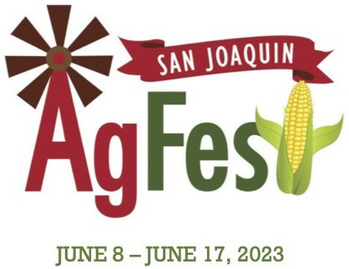 

Dear potential 4-H experience supporter,

Hello, my name is Andrew Hilbert and I’m 11 years old. I currently attend Woodbridge Elementary school and will be going to middle school soon. I really enjoy school, learning as much as I can and I’m very determined to go to college. I will be taking all honor classes in middle school which I’m very excited and proud of. Besides schooling I also enjoy swimming, going camping with my family, going to church camp, cooking on my BBQ and of course raising my pig.

This is my first year in the Tokay Colony 4-H group and my first year taking an animal to the San Joaquin AgFest. I choose to take a pig this year because my mom raised pigs when she was a kid and told me all about how much fun they are. I was a little bit scared of raising a pig because I know it will be very sad for me to sell my pig, but I also know the experience is worth it. I purchased a Berkshire pig in January and named him Tobi. I have learned a lot about Tobi and raising him especially since this experience is so new to me and a learning process. Raising my pig, Tobi, has taught me how to be more responsible, organized and determined to do my best for both me and my pig. I have learned about how to show a pig, groom Tobi, about medications, how to clean his pen, give him a bath and most of all rub his belly because it’s his favorite thing besides having a bath.

I would like to invite you to come out to the San Joaquin AgFest and watch me show my pig, Tobi. I will be showing him in the market class on June 14th and showmanship on the 15th. I’m excited to show everyone what I have learned in the ring and show off Tobi. Showing a pig is very new to me, but I feel me and Tobi work very good together. I started working with him as soon as I brought him back to the farm so he is very calm and tame.

I would also like to invite you to come watch me sell my pig on June 17th in the 4-H swine ring starting at 9:30am and I would appreciate your support with my first 4-H pig raising, showing and selling experience. I’m a little sad I will have to say goodbye to my first pig but I’m already looking forwarded to raising a pig again next year. If you are not able to attend the auction, bidding is also available online at www.stockshowauctions.com. If you are not able to purchase my pig in the auction I would greatly appreciate any possible support, which can be done as an add-on to my 4-H pig project with the San Joaquin AgFest. All the profit from me showing, raising and sell my pig, Tobi, will go into my college fund because I hope to attend the University of Southern California one day.

Thank you for your time, potential support and I hope to see you at the San Joaquin AgFest, so I can show you Tobi and all that I have learned raising him. If you have any questions or would like to know more about me or Tobi, my pig, please email me at: ahilbert620@gmail.com

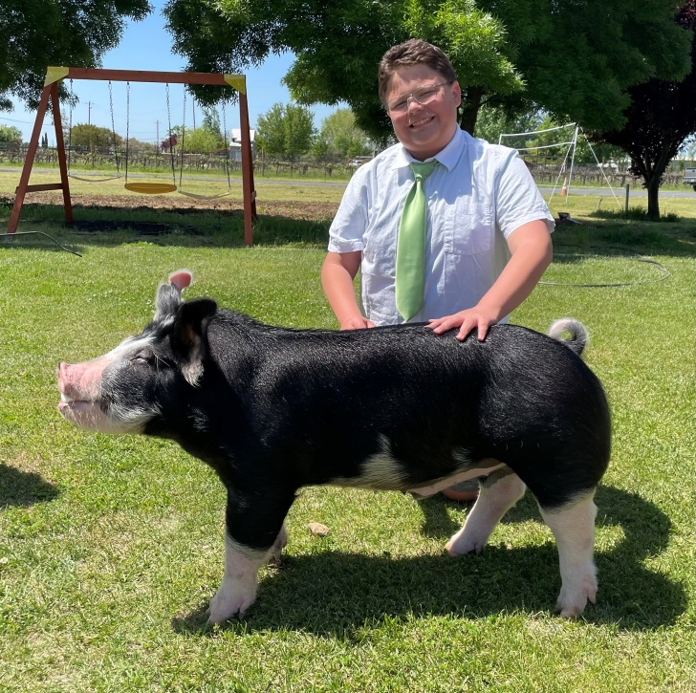

Thank you,

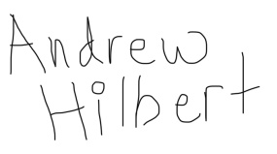

Andrew Hilbert

18956 Lilac St.

Woodbridge, CA 95258