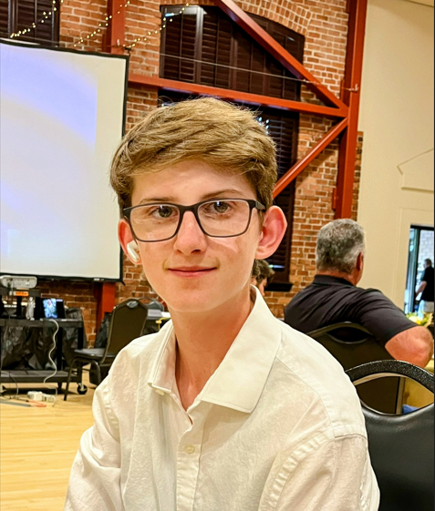
May 25, 2023

Att:
Name
Address
City, State, Zip Code

To whom is may concern,
My name is Douglas Haywood, and I am a member of the Lodi FFA Chapter 1. I am a Freshman in High School, and this is my first year participating in the San Joaquin County Ag Fest. This year I will be showing my Market Swine project. We will be moving into the Fairgrounds on Sunday, June 11th and showing my Market Swine Tuesday June 13, 2023. I would like to invite you to attend this year’s Auction on Saturday, June 17th beginning at 9:30 am in the Dave Luis Memorial Swine Ring at the San Joaquin County Fairgrounds.
At school, I am actively participating in the FFA program, Lodi High Cross Country and Track & Field. I plan to continue all 4 years of high school in all of these programs to enhance my skills & knowledge in Agriculture, while being a team player. I am hoping to raise funds to purchase and cover costs for a Swine in 2024 and I am saving for a car and college. I have been working diligently with my swine since February 25th, spending many hours caring for my animal, partnering with my fellow FFA teammates with our clean up schedules and practicing showmanship. I really learned a valuable lesson my first year when on May 15, 2023, my swine had a seizure and passed away. I have learned in agriculture even with hard work that animals are not a guarantee, and you don’t get your money back. I was very lucky to have had the opportunity to purchase one additional pig the school had just in case. However, I only have 3 weeks to really practice and prepare for fair with this new pig. Even with the challenges I have faced, I have enjoyed the teamwork with other students and look forward to the program again for next year.
Your participation in this year’s Ag Fest auction is greatly appreciated, as many students have put in countless hours in order to be able to be successful and sell their market animal. If you would also be interested in completing an Ag Education Donation Scholarship in lieu of or addition to purchasing at the auction, please go to sanjoaquinagfest.org and under Ag Fest 2023 click the Ag Education Scholarship Program. Please feel free to come to the Ag Fest anytime to talk to me or ask me about my market project!
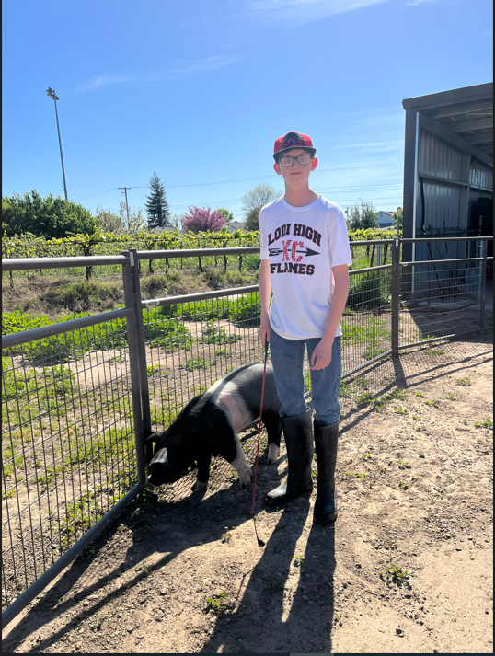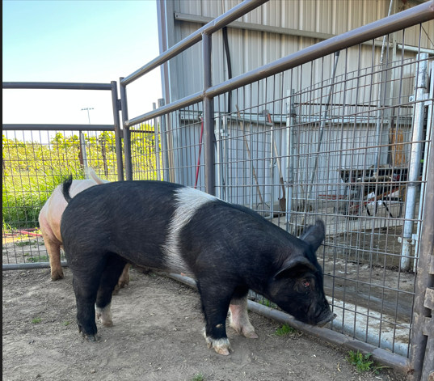
Douglas Haywood
209-329-4927

Sincerely,

