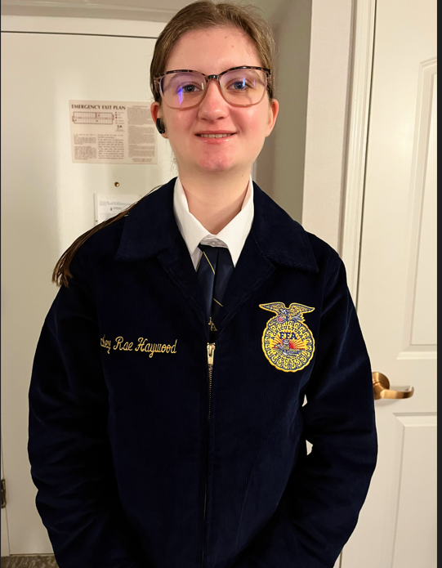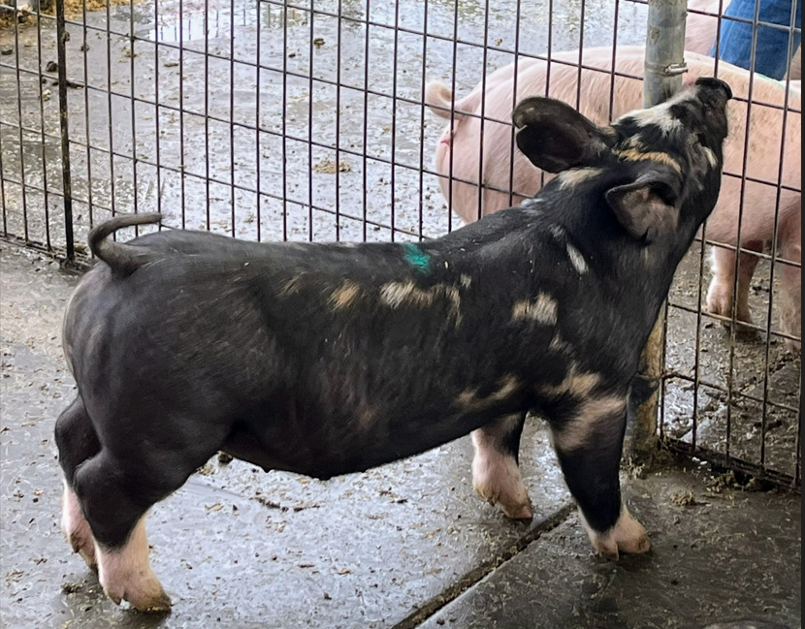
May 25, 2023

Company Name
ATTN: Manager or Ownership
Address
City, State, Zip Code

To whom is may concern,

My name is Hailey Haywood, and I am a member of the Lodi FFA Chapter 1. I am a Junior in High School, and this is my second year participating in the San Joaquin County Ag Fest. Last year I participated in Market Chickens and this year I am participating in Market Swine’s. This year I will be showing my Market Swine project and we will be moving into the Fairgrounds on Sunday, June 11th and showing my Market Swine Tuesday June 13, 2023. I would like to invite you to attend this year’s Auction on Saturday, June 17th beginning at 9:30 am in the Dave Luis Memorial Swine Ring at the San Joaquin County Fairgrounds.
At school, I am in Ag 3 Horticulture and participated in the 3rd Grade Ag Fest at the Lodi Grape Festival Grounds, the State FFA Conference in Ontario, Ca, volunteered to work for the 2022 election at the local election voter booth in service to our democracy, and this year’s San Joaquin AgFest with my Market Swine. I am also very active in my Theatre Arts College Prep class and have volunteered for the last 2 years for the Lodi High School Drama program performances, a participant of the Drama’s Club improvisation team, and I am Secretary of the Drama Club this year. I have also been involved in various community service organizations including Love Lodi 2023 as well as volunteering my time at the Lodi Animal Shelter. All of these activities have taught me to work hard, be observant, be a dedicated student, gain & strengthen my leadership skills, build my confidence, communication, and trust and teamwork, and most of all how best to serve as a leader in multiple situations.
I am hoping to raise funds to help purchase and cover costs for a Swine in 2024 and saving for college as I will be going to a 4 year college to major in Marine Biology and hoping to use all of the valuable skills and basic knowledge and other things, I have learned through the FFA program, to create a successful career. I have been working diligently with my swine since February 25th, spending many hours caring for my animal, partnering with my fellow FFA teammates with our clean up schedules and practicing showmanship. Even though it is hard work I have enjoyed the teamwork with other students and look forward to my Senior year in the program next year.
Your participation in this year’s Ag Fest auction is greatly appreciated, as many students have put in countless hours in order to be able to be successful and sell their market animal. If you would also be interested in completing an Ag Education Donation Scholarship in lieu of or addition to purchasing at the auction, please go to sanjoaquinagfest.org and under Ag Fest 2023 click the Ag Education Scholarship Program. Please feel free to come to the Ag Fest anytime to talk to me or ask me about my market project!
Hailey Haywood
209-329-7144

Sincerely,
