May 15th 2023

Dear Community Supporter,

Hello, my name is Charlie Bottoms. This is my year first year in Lockeford Grange and this year is my second year raising a steer. I am writing to ask you to participate in the San Joaquin Agfest Junior Show and Auction on June 17th at 8am to bid on my Steer. I would greatly appreciate it if you would support our local Grange club. My steer’s name is Calvin and is a Charolais cross with outstanding genetics.

I have been working with Calvin almost every day for 20-30 minutes and he responds well. He loves to eat his food and loves treats. He is a very nice steer.

I really hope you’ll consider bidding/buying my steer, Calvin. Please contact me or let me know at [jbottoms@lindenusd.com](mailto:jbottoms@lindenusd.com) or call me at (209)-614-0201.

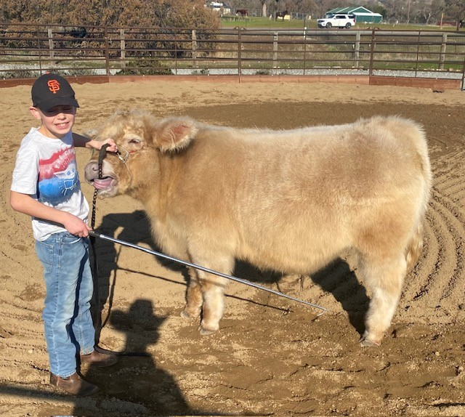Thank you for your support,

Charlie Bottoms

8701 S. Hwy 26

Valley Springs, CA 95252

