April 19, 2022

Dear Community Supporter,

Hello, my name is Ashley Bottoms. This is my Second year in Linden FFA and this year I decided to raise a steer. I am currently your Jr. Agfest Board President. I am writing to ask you to participate in the San Joaquin Agfest Junior Show and Auction on June 17 at 8am to bid on my steer. This auction will be in-person. I would greatly appreciate it if you would support our local FFA chapter. My steer’s name is Earl. He is an angus cross with outstanding genetics.

I have been working with Earl every day for 20-30 minutes and he responds well. I really hope you’ll consider bidding/buying my steer, Earl. Please contact me or let me know at [jbottoms@lindenusd.com](mailto:jbottoms@lindenusd.com) or call me at (209)-614-0201.

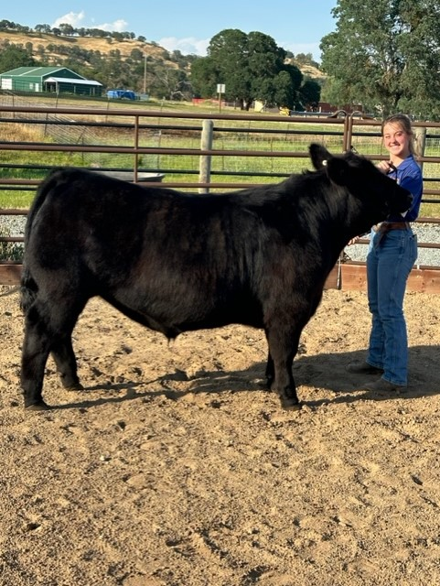Thank you for your support,

Ashley Bottoms

8701 S. Hwy 26

Valley Springs, CA 95252

