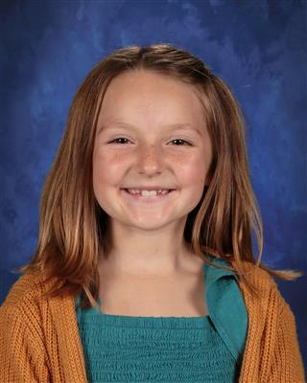

Dear Potential Buyer,

My name is Emerson Reynolds. I am 9 years old and I will be going into the 4th grade at Calhan Elementary School. Outside of school I like to play basketball and baseball for the Calhan Bulldogs. I also enjoy playing with my dogs Ruger and Daisy. I have a cow named Lucy that I showed in the 2022 Bucket Calf Show at the El Paso County Fair. She will hopefully be a mom this year and I hope she has a healthy calf to grow my own herd.

This is my very first year in 4H and I am part of the Calhan Ranch Hands 4H Club. For my very first 4H project I decided to raise market swine. I am currently raising 2 market pigs. They are both Hampshire pigs and look just like Oreo cookies so I decided to name them Cookie and Oreo. Cookie was born in December and we purchased her from Torpedo Farms in Pueblo, CO. She loves the water and loves digging in the mud. Oreo was born in January and we purchased her from the King Family in Calhan, CO. Oreo is very energetic and loves getting her neck rubbed. They both love chewing on my boots.

I have learned a lot about raising my pigs this year. I have learned how to properly feed my pigs the right food so they can be healthy. I have learned about being responsible by making sure they are fed at the right times. I know how to care for them when they are sick or injured. I also know how to exercise them properly by walking them every day. My favorite part about raising these pigs has been getting to know their personalities and watching them grow.

I will be participating in the 2024 El Paso County Fair and I would like to invite you to come see my market swine projects. I will be in the arena on Tuesday July 16th at 6:00pm showing my market swine projects. On Saturday July 20th from 10:30am-12:00pm, there will be a Buyers BBQ at Swink Hall at the El Paso County Fairgrounds. I encourage you to stop by and ask me any questions you may have about my market swine projects. Please visit <https://www.epcjrlivestocksale.com/buyers> to register and to participate in the El Paso County Jr. Livestock Sale. There you will also find helpful information on meat lockers and our buyback program that can also benefit those in need by providing good quality meat to the Colorado Springs Rescue Mission. There is also an Add-On option if you choose to opt out of purchasing an animal and would like to directly donate to support my project. If you cannot attend in person, you may bid online at [https://www.stockshowauctions.com/buyer#](https://www.stockshowauctions.com/buyer).

I appreciate your time and consideration and look forward to seeing you at the El Paso County Jr. Livestock Sale on July 20th at 1:00pm.

Sincerely,

Emerson Reynolds

